Godaddy Hosting Set-Up

**Web Hosting overview**

A **web hosting service** is a type of [Internet hosting service](http://en.wikipedia.org/wiki/Internet_hosting_service) that allows individuals and organizations to make their [website](http://en.wikipedia.org/wiki/Website) accessible via the [World Wide Web](http://en.wikipedia.org/wiki/World_Wide_Web). Web hosts are companies that provide space on a [server](http://en.wikipedia.org/wiki/Server_(computing)) owned or leased for use by clients, as well as providing [Internet](http://en.wikipedia.org/wiki/Internet) connectivity, typically in a [data centre](http://en.wikipedia.org/wiki/Data_center). Web hosts can also provide data centre space and connectivity to the Internet for other servers located in their data centre, called [colocation](http://en.wikipedia.org/wiki/Colocation_centre), also known as *Housing* in Latin America or France.

**Why Godaddy**

In this project econference specific it’s highly recommended that we stay with godaddy for the only reason we are testing using their environment for development and testing. If we up to setup with another hosting account we could encounter different server setting that would interfere on what we have already tested.

**Registration**

1. Go to <https://au.godaddy.com/>

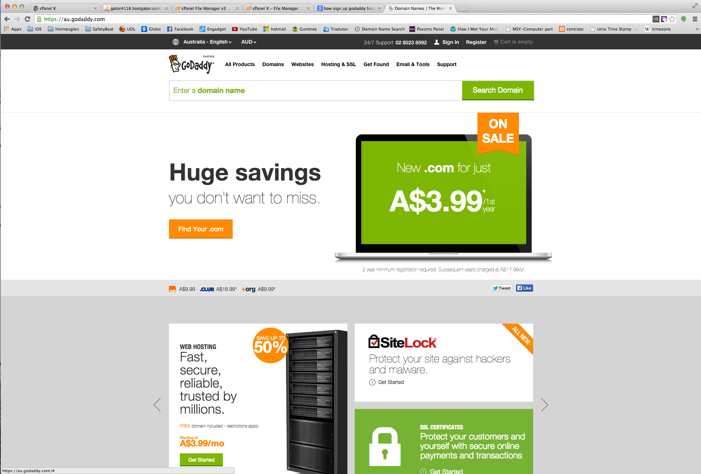

1. Hover the option **Hosting & SSL** and choose the option **Web Hosting** or access the link: <https://au.godaddy.com/hosting/web-hosting.aspx?ci=9009>

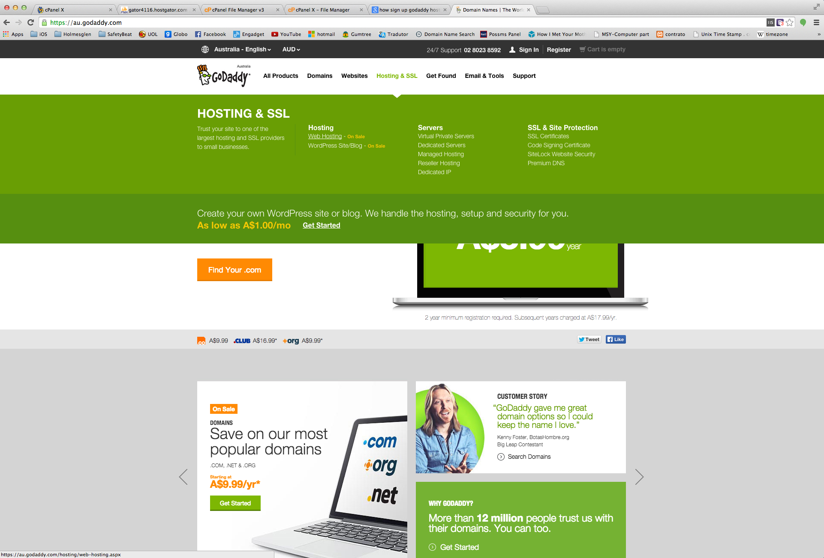

1. Click on the green button **Get Started** to begin the registration process



1. Next you will have to choose a plan, in this phase of the project you are not required to select a advance hosting, you can pick the most affordable.

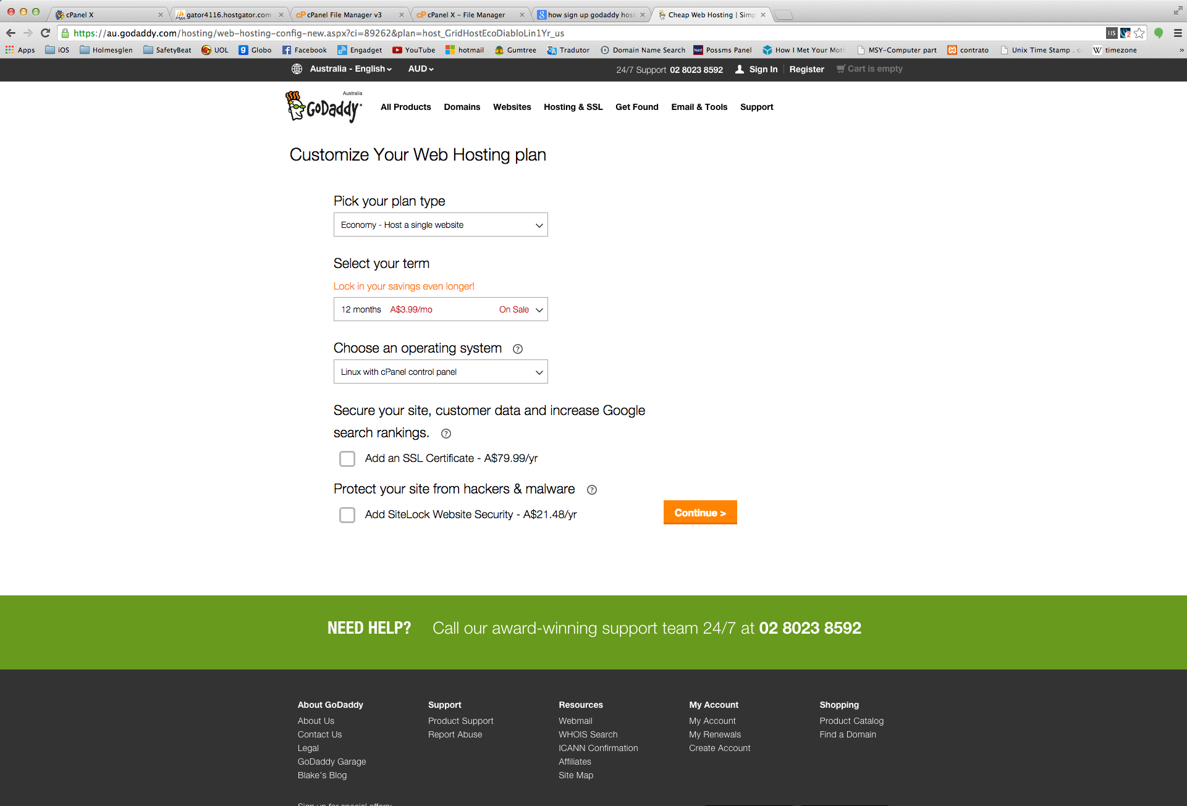

1. Unless you want to register a domain, click on **I don't want my free domain** button

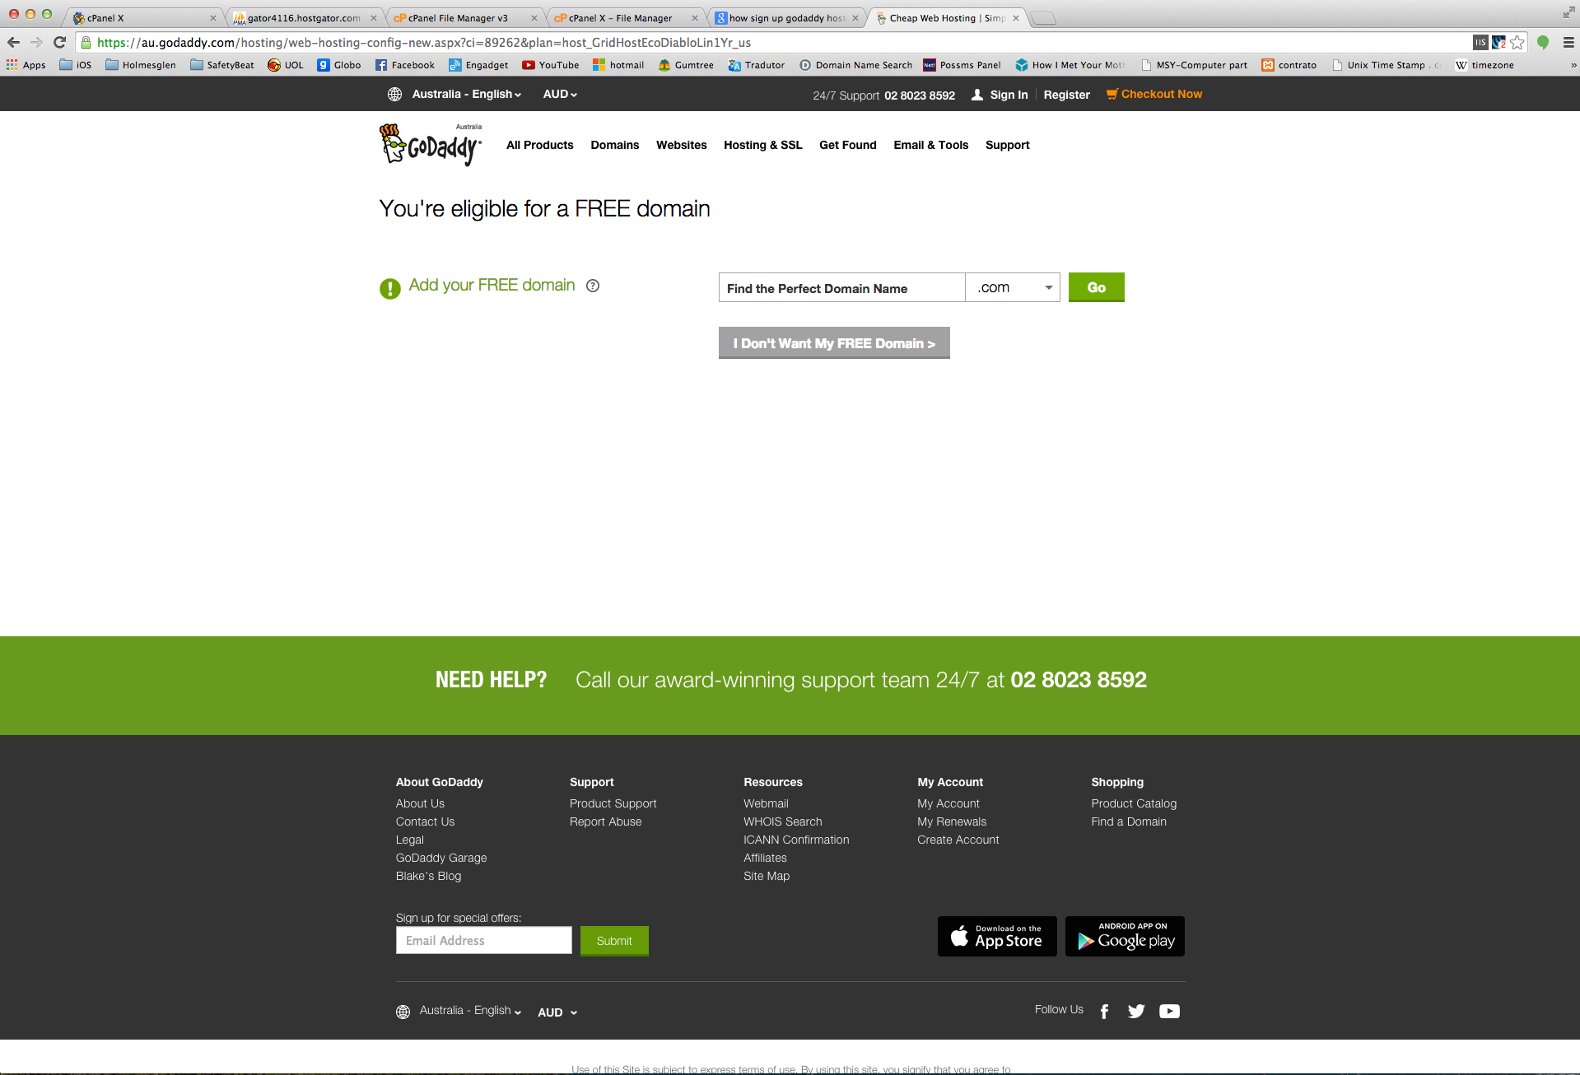

1. Click on **Process to Checkout** button to finalize your order and enter the details and payment method.

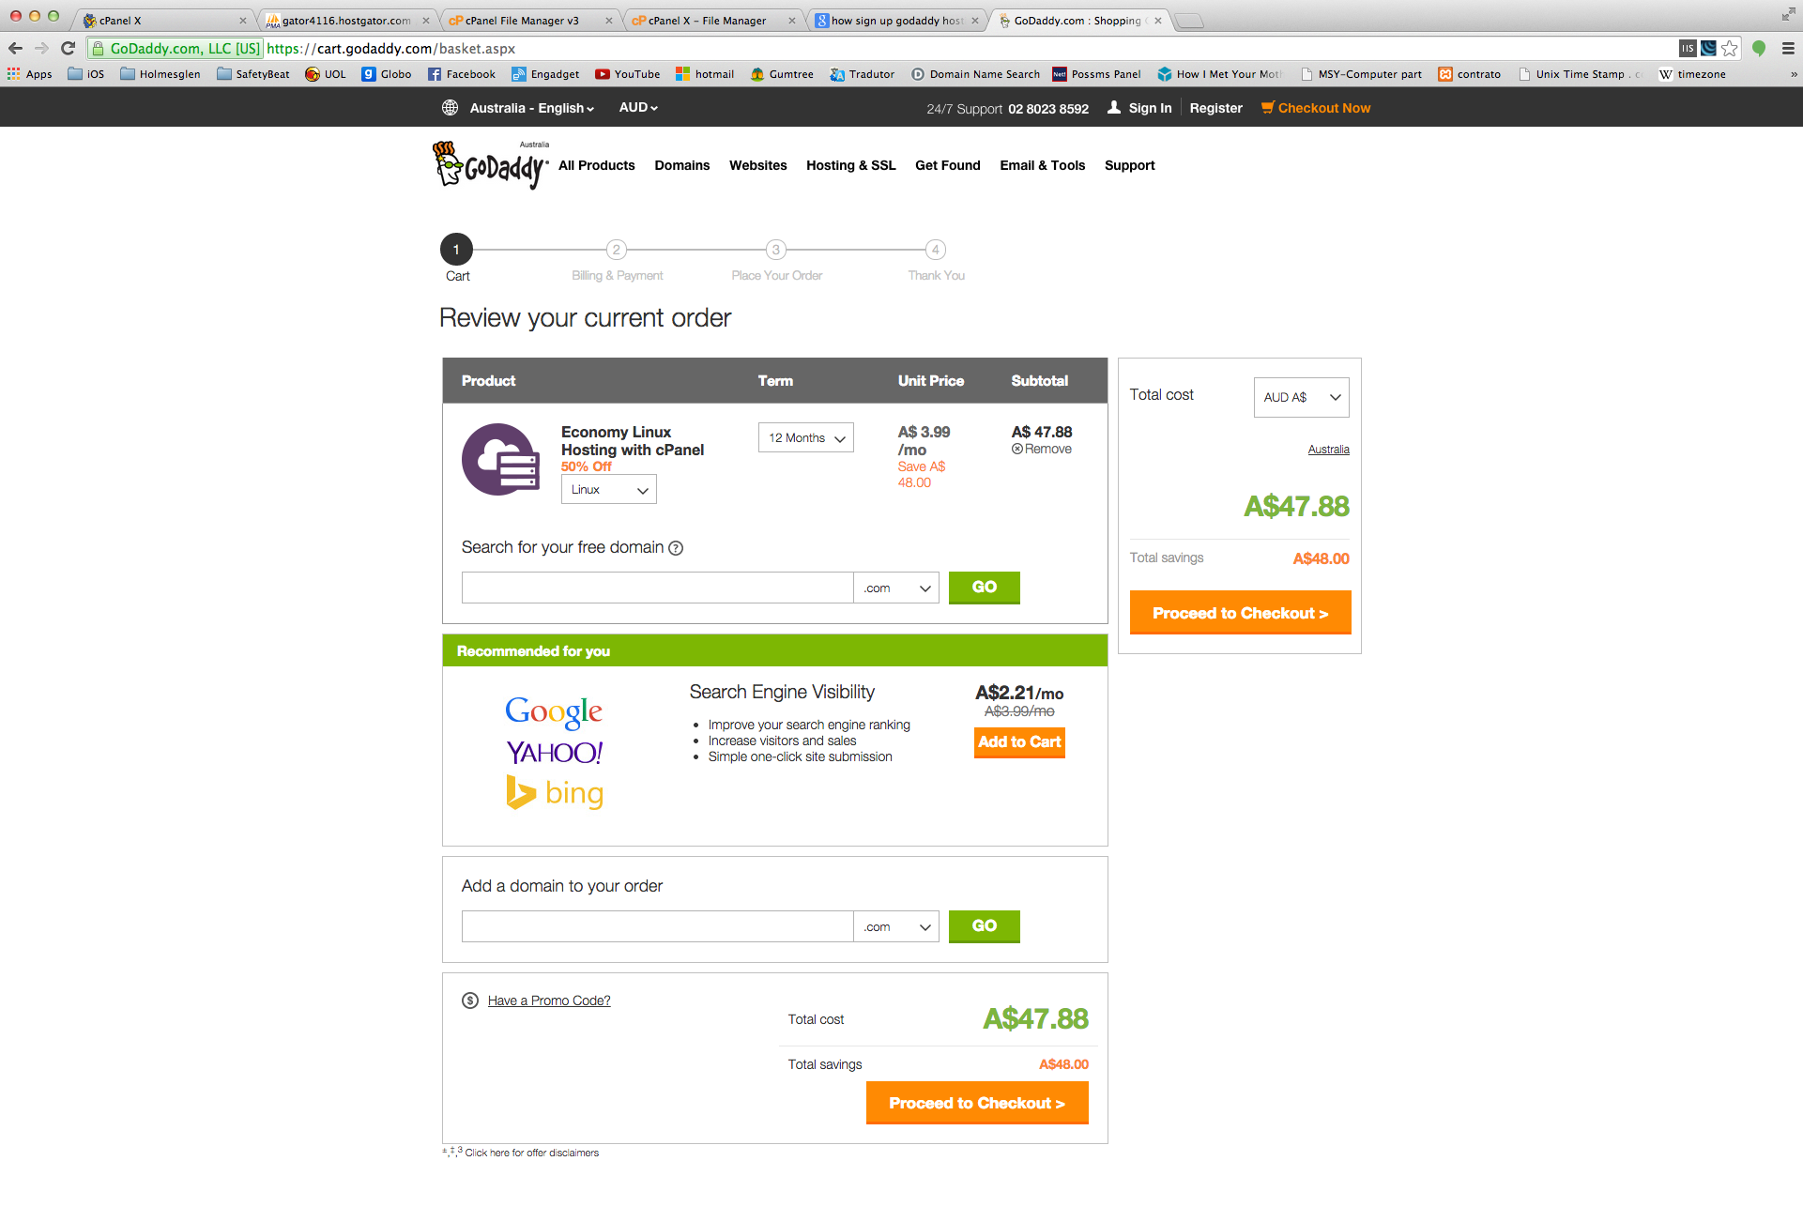

1. If you have already an account with Godaddy you can use it, simple login with your credentials otherwise click on **Continue** bellow the option “New Customer”

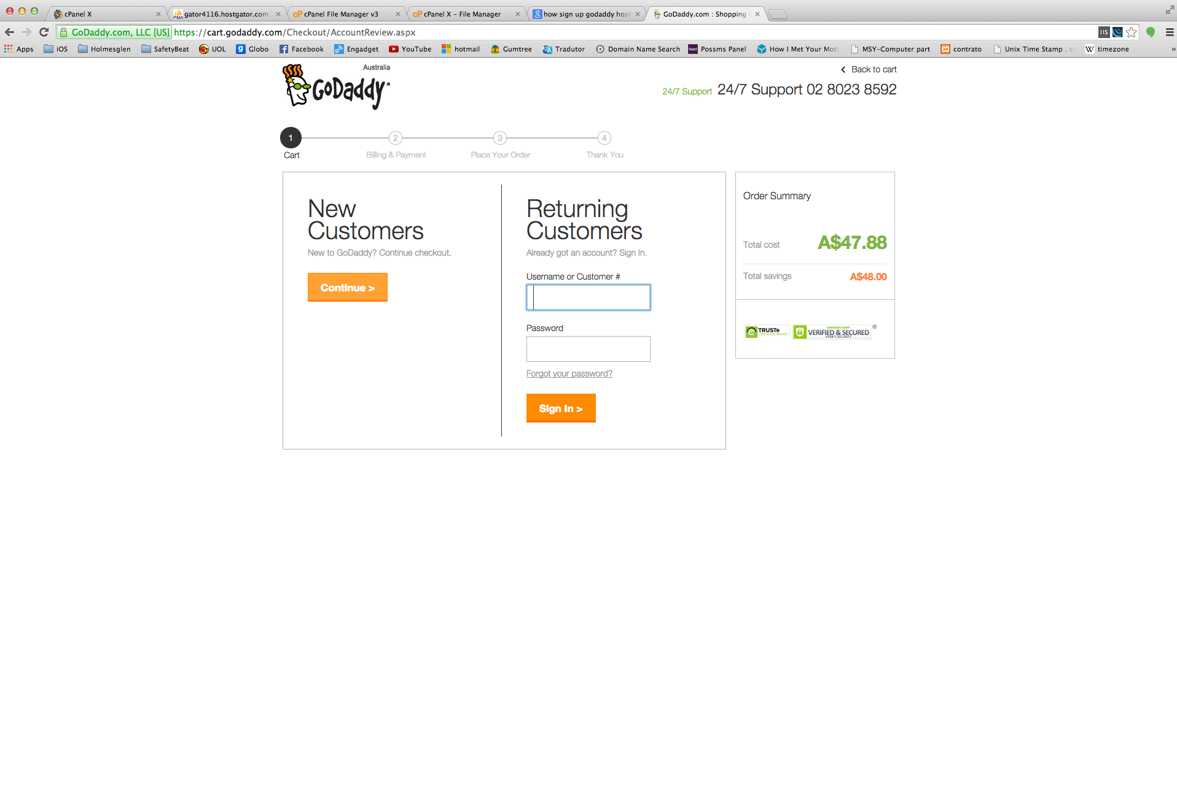

1. Enter your personal information and your preferred method of payment to complete the registration process.

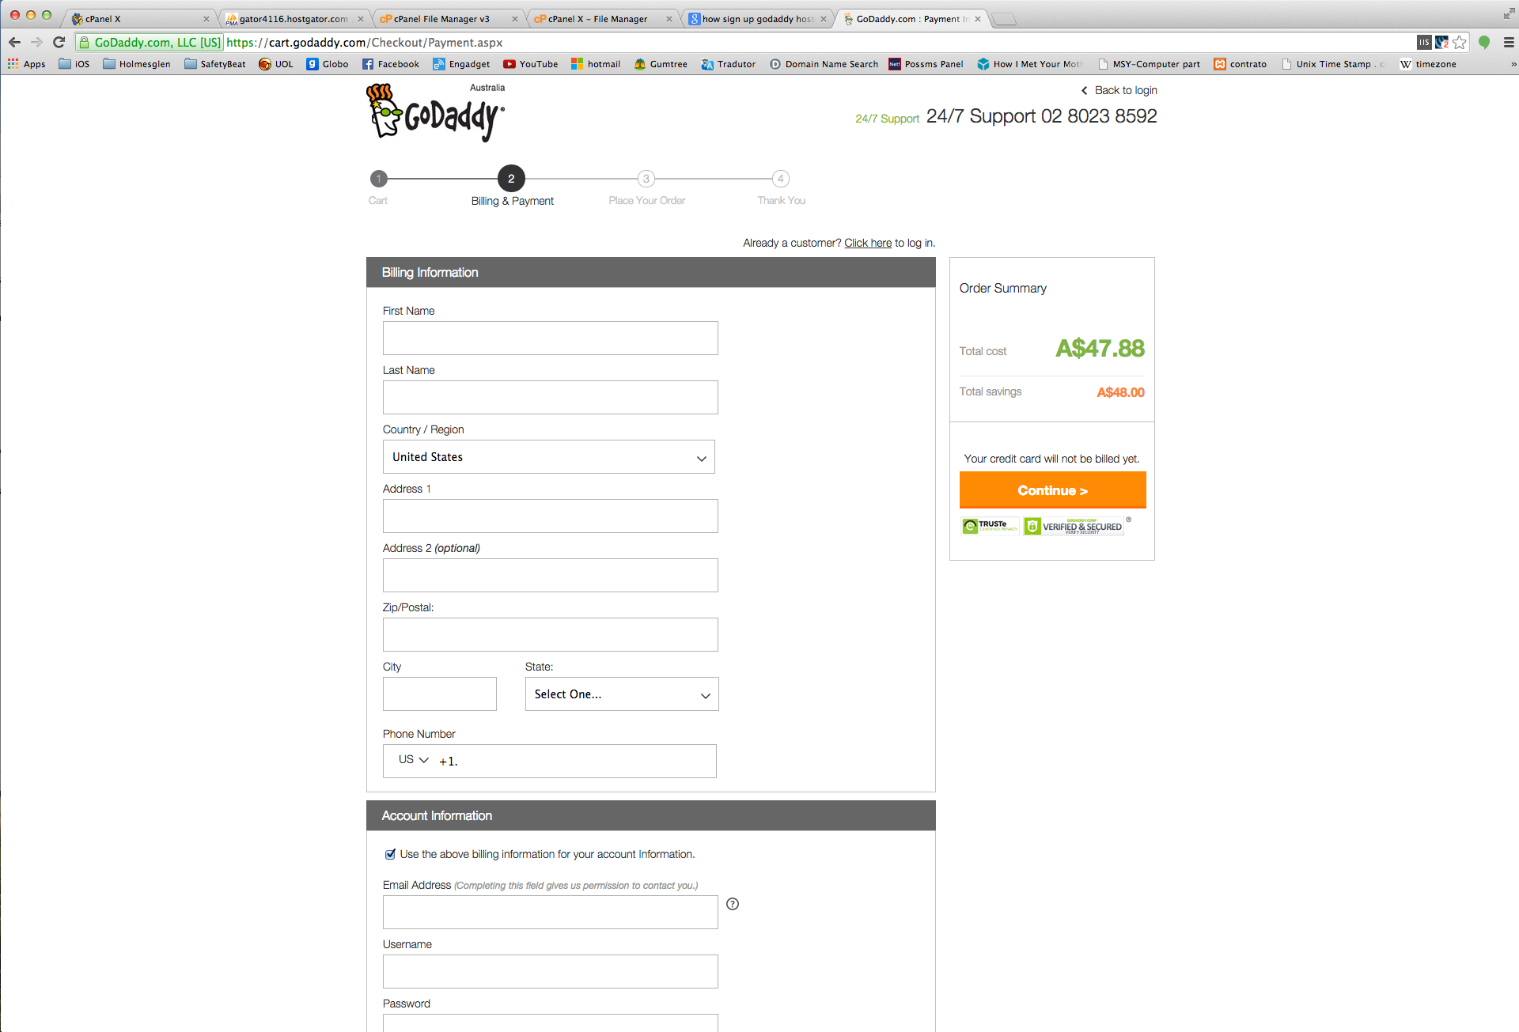

1. Congratulations, you have signup for the hosting, an Welcome email will be sent to you with the login details to the new hosting.

Source:

<https://au.godaddy.com/>